**Data Management**

***Managerial Question***

**Question 1: How much revenue is being generated from members vs. non-members?**

Rationale: Annie wants to evaluate the effectiveness of the membership program in driving sales and repeat visits.

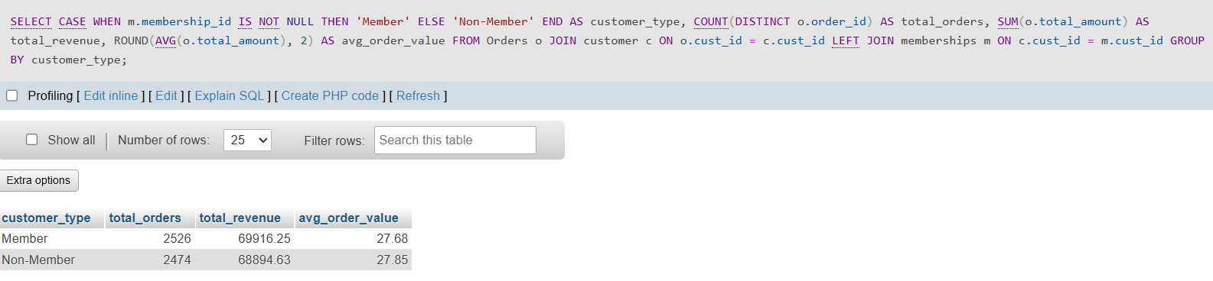

This query helps Annie understand the difference in spending between members and non-members at Bites & Brews. It checks how many total orders each group placed, how much money they spent in total, and what the average value of each order was. The results show that members made more orders and spent a little more money overall compared to non-members. However, both groups spend about the same amount on each order. This means the membership program is helping bring people back to buy again, but it’s not making them spend more each time they visit. Annie can use this insight to improve the membership program—for example, by offering special bundle deals or bigger discounts to increase the average order size for members.

**Question 2: Which staff members generate the highest average order value?**

Rationale: Annie wants to identify high-performing staff and explore whether they influence upselling behaviour.

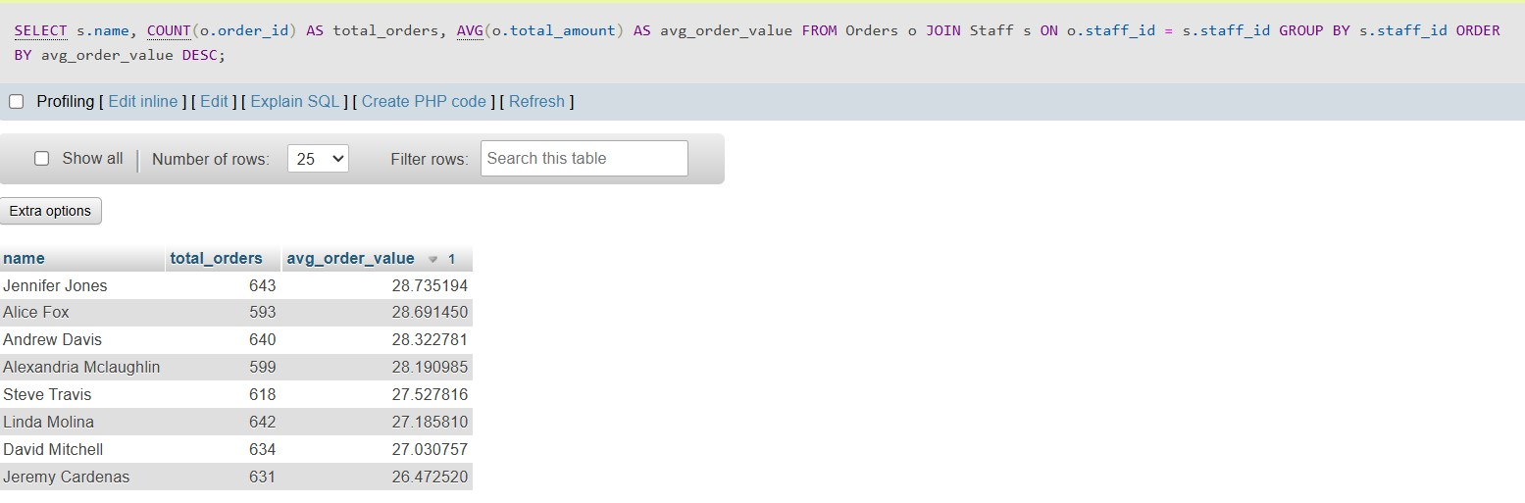

This query gives Annie a quick overview of how each staff member is performing in terms of the number of orders they handle and the average value of those orders. By joining the Orders and Staff tables, it shows how many orders were taken by each staff member (total_orders) and what the average order value was (avg_order_value). The results are sorted by average order value, so Annie can easily see which team members are bringing in larger sales per order. For example, Jennifer Jones handled the most orders with a strong average value, while others like Jeremy Cardenas have a lower average. This information is useful because it helps Annie identify top performers who may be good at upselling or handling high-value orders. It can also help her spot staff who might need more support or training. Overall, this query allows Annie to make staffing decisions backed by real data—like assigning top staff to peak hours or mentoring others to improve their performance.

**Question 3: Which product categories are generating the most revenue monthly, and are there any seasonal trends?**

Rationale: Annie wants to identify which types of items—like snacks, drinks, or fusion foods—perform best in terms of revenue across different months. This can help her plan future promotions, menu adjustments, and supplier orders more effectively.

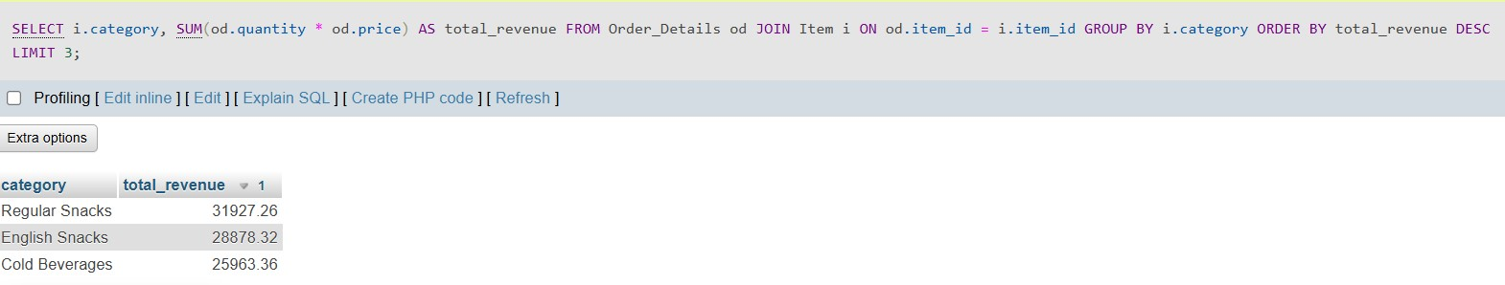

This query helps Annie identify which menu categories are generating the most revenue overall. By joining Order_Details with Item, it calculates total revenue for each item category by multiplying the quantity sold by the price. Then, it groups results by category and ranks them in descending order to highlight the top three. The output shows that Regular Snacks have earned the highest total revenue, followed by English Snacks and Cold Beverages. This insight is highly actionable for Annie, as it guides her to focus more on what sells best. For instance, she can run promotions, create bundle offers, or allocate inventory more efficiently for these categories. It also gives her confidence in which suppliers and ingredients to prioritize to meet ongoing demand.Understanding top-performing categories not only supports better inventory and menu decisions but also strengthens the café’s ability to remain competitive and profitable. It’s a simple yet powerful use of data to steer smarter business strategy.